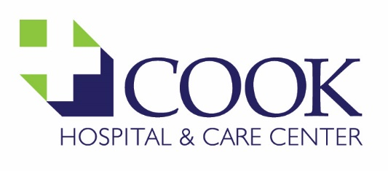 | DISTRIBUTION:
 | EFFECTIVE DATE: | 4/2008
TITLE/SUBJECT:  Collections Policy & Procedure | REVISED: | 11/1/2023; 10/14/2024
TITLE/SUBJECT:  Collections Policy & Procedure | REVIEWED DATES: | 11/2008; 9/2009; 1/2010; 2/2012; 2/20/2014; 10/15/2014; 1/2016; 3/28/2017; 2/9/2018; 1/7/22; 11/1/2023, 1/19/2024; 10/14/2024; 10/08/2025
WRITTEN BY: Stacy Will | APPROVED BY: Board of Directors

POLICY: When a patient’s account is deemed the patient’s responsibility/self-pay, a 150-day reasonable collection effort will be performed either after their first statement has been generated, or after the uninsured Community Benefit Process has been completed as follows:
PROCEDURE:
- For any uninsured patient, contact will be made with the patient to have him/her apply for the Community Benefit Program. This will occur within 1-2 weeks after the date of service.
  - While a patient is going through the application process (starts at the point of the application being mailed or the date we met in person to discuss, and ends 30 days thereafter), we will not initiate the following until it is determined that the patient is not eligible for a discount or does not comply with or applies for the program after the timeframe allowed.
    - Offer a payment plan.
    - Change the terms of a payment plan that may already be in place.
    - Offer a line of credit, or loan.
    - Refer the account to any in-house collection activity (i.e., collection phone calls asking for payment or status of payment, collection letters), or to the collection agency and/or to the MN Department of Revenue Recapture.
    - Accept a credit card payment of over $500.00 for the debt owed.
  - The collections procedure will begin 30 days thereafter and the patient is deemed noncompliant in responding to the Community Benefit Program, or 30 days after a discount amount has been approved and allocated to the account if no payment has been made.

- A phone call attempt is made within the first 30-days after the date of service to patients that have a self-pay balance (except for uninsured patients that the Business Office staff are working through the Community Benefit Program process with).
- Patients will receive a statement showing a balance due that provides an itemization of services and procedures administered during the encounter. Thereafter, the patient will receive a statement each month showing the forwarding balance that would be currently due on the account.

- Mail a Financial Assistance Letter to all self-pay patients within the first 60 days, whether the patient is insured or uninsured to educate them on our Community Benefit Program.

- When an account is 90 days into this process and there has been no form of communication or payment received from the patient, mail a First Notice of Non-Payment Letter.

- When the account is 120 days into this process and there has been no form of communication or payment received from the patient, telephone the patient and request payment in full or to set up a payment plan/contract.
  - If telephone contact is not made with the patient, or if patient was not receptive to setting up a plan or making a payment, mail the 30-Day Notice Collection Letter.

- When a patient is on a payment plan/contract and has not paid on the account for 60 days from the last payment received, telephone the patient.
  - If telephone contact is not made with the patient, mail a Contract Pre-Bad Debt Letter.

- An account is deemed uncollectible when a patient cannot be located through in-house skip tracing methods when the AR Tech receives a mail return.

- If there is no form of communication or payment received after the above steps have been completed and the balance remains due at or after 150 days, verify the account does not qualify for Medical Assistance (MA) or the Sliding Fee Scale (SFS):
  - If the account qualifies for MA or SFS, process the account accordingly.
  - If the account does NOT qualify for MA or SFS:
    - Call the patient as a last attempt.
    - If unsuccessful in receiving payment, on the last business day of the month, transfer all applicable accounts to a Bad Debt status in Meditech.
    - The collection agency report will be printed and reviewed within 2-4 weeks thereafter for approval of placement and then submitted to the collection agency and the MN Revenue Recapture Program.

